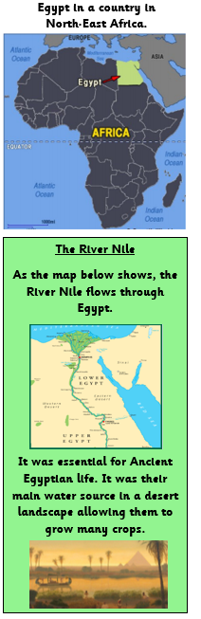**Ancient Egypt Knowledge Organiser**

|  |  |
| --- | --- |
| Key Vocabulary | |
| Ancient Egypt |  |
| Hieroglyphics | Ancient Egyptian writing |
| Civilisation | A person who studies human history through the excavation of sites and the analysis of artefacts and other physical remains. |
| Monument | An archaeologist who specialises in Ancient Egypt |
| Irrigation | Discovered in 1799. It was helpful because it has the same text written in three different forms so people were able to translate what the hieroglyphs meant. |
| Archaeologist | At the top of the order, thought of as a god. The kings of Ancient Egypt. |
| Excavation | Paper that the Egyptians made from reeds to write hieroglyphics on. |
| Scribe | A burial place for famous Egyptians such as pharaohs. They were buried with their belongings for use in the afterlife. |
| Cartouche |  |
|  |  |
| Mummification | The process of preserving the body of a person to allow them to enter the afterlife. |

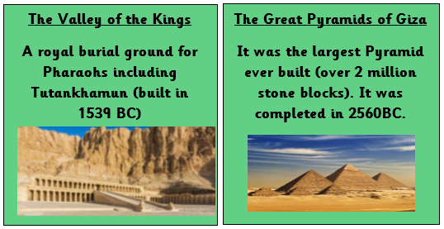

Key information

* **Ancient Egypt is a particularly important era of ancient history because of the many achievements of the Ancient Egyptian people.**
* **Egyptian Civilisation began 5,000 years ago in 3100 BC and lasted around 3,000 years.**
* **Tutankhamun became a pharaoh in 1332 BC after his father’s death when he was only 9/10 years old. He reigned for 10 years.**
* **In 1922 Howard Carter (an Egyptologist) discovered Tutankhamun’s tomb.**
* **The civilisation continued until the death of Cleopatra VII in 30 BCE when Egypt fell to the Roman Empire.**
* **Egyptians believed in immortality and an afterlife, developing complex burial rituals including mummification.**

**Obelisks**

**Pointed stone pillars to commemorate the achievements of kings, queens and wealthy Egyptians to worship the gods.**

**The Rosetta Stone**

**Discovered in 1799, helped to decode hieroglyphics.** 