Books we will be reading

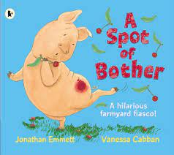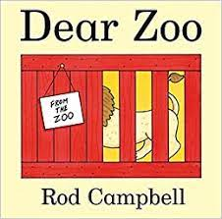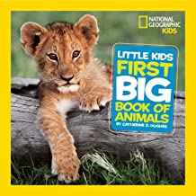

Animals

Key vocabulary

Reception will be finding out all about animals for the next few weeks. Below is a list of the key vocabulary that the children will be taught.

|  |  |  |  |  |
| --- | --- | --- | --- | --- |
| habitat C:\Users\rtucker\AppData\Local\Microsoft\Windows\INetCache\Content.MSO\6DD3D63A.tmp | pet C:\Users\rtucker\AppData\Local\Microsoft\Windows\INetCache\Content.MSO\ACD0F0BF.tmp | zoo C:\Users\rtucker\AppData\Local\Microsoft\Windows\INetCache\Content.MSO\FF54F825.tmp | wild Animals in the wild | World Animal Protection | tame C:\Users\rtucker\AppData\Local\Microsoft\Windows\INetCache\Content.MSO\1304A240.tmp |
| farm Farm-Based Food Waste Repurposing Provides a Pathway to a Healthier Planet  - Vanguard Renewables | cow C:\Users\rtucker\AppData\Local\Microsoft\Windows\INetCache\Content.MSO\664E7687.tmp | giraffe Cape Giraffe - Giraffa camelopardalis giraffa – Ben Rothery | penguin C:\Users\rtucker\AppData\Local\Microsoft\Windows\INetCache\Content.MSO\C91D054A.tmp | seal C:\Users\rtucker\AppData\Local\Microsoft\Windows\INetCache\Content.MSO\587BE8.tmp |
| pig C:\Users\rtucker\AppData\Local\Microsoft\Windows\INetCache\Content.MSO\7677824E.tmp | calf C:\Users\rtucker\AppData\Local\Microsoft\Windows\INetCache\Content.MSO\AAE2738C.tmp | elephant C:\Users\rtucker\AppData\Local\Microsoft\Windows\INetCache\Content.MSO\BBDFD7A.tmp | tiger C:\Users\rtucker\AppData\Local\Microsoft\Windows\INetCache\Content.MSO\704D9398.tmp | whale Humpback Whale | NOAA Fisheries |
| piglet C:\Users\rtucker\AppData\Local\Microsoft\Windows\INetCache\Content.MSO\7A949A2F.tmp | sheep C:\Users\rtucker\AppData\Local\Microsoft\Windows\INetCache\Content.MSO\46E41315.tmp | rhino Rhino rigging animation 3D - TurboSquid 1197965 | zebra C:\Users\rtucker\AppData\Local\Microsoft\Windows\INetCache\Content.MSO\ECCAFF0.tmp | dolphin C:\Users\rtucker\AppData\Local\Microsoft\Windows\INetCache\Content.MSO\60F3CB7E.tmp |
| horse C:\Users\rtucker\AppData\Local\Microsoft\Windows\INetCache\Content.MSO\73BC043C.tmp | lamb C:\Users\rtucker\AppData\Local\Microsoft\Windows\INetCache\Content.MSO\49DDC1AA.tmp | monkey Monkey High Res Stock Images | Shutterstock | snake How Did Snakes Lose Their Legs? | HowStuffWorks | fish How Amazonians saved a 'Terminator' of the fish world - CNN |
| foal C:\Users\rtucker\AppData\Local\Microsoft\Windows\INetCache\Content.MSO\1DC85F9F.tmp | cheetah C:\Users\rtucker\AppData\Local\Microsoft\Windows\INetCache\Content.MSO\DF85AA05.tmp | lion C:\Users\rtucker\AppData\Local\Microsoft\Windows\INetCache\Content.MSO\3C886F5B.tmp | crocodile C:\Users\rtucker\AppData\Local\Microsoft\Windows\INetCache\Content.MSO\87179D21.tmp | shark C:\Users\rtucker\AppData\Local\Microsoft\Windows\INetCache\Content.MSO\15FFCD7.tmp |