Nursery will be learning about growing over the next few weeks. Below is a list of the key vocabulary that the children will be taught.

Some of the books we will be reading

Growing

Key vocabulary

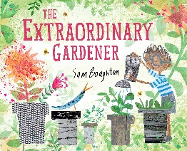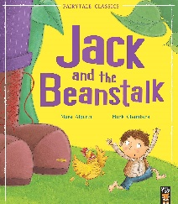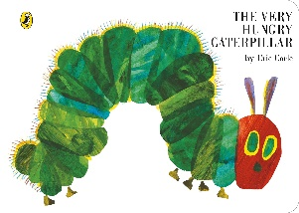

|  |  |  |  |
| --- | --- | --- | --- |
| tree C:\Users\rtucker\AppData\Local\Microsoft\Windows\INetCache\Content.MSO\77AF3C42.tmp | leaf C:\Users\rtucker\AppData\Local\Microsoft\Windows\INetCache\Content.MSO\7D6D7CAE.tmp | plant C:\Users\rtucker\AppData\Local\Microsoft\Windows\INetCache\Content.MSO\E3F3CEC.tmp | petalC:\Users\rtucker\AppData\Local\Microsoft\Windows\INetCache\Content.MSO\FFF142F8.tmp |
| flower C:\Users\rtucker\AppData\Local\Microsoft\Windows\INetCache\Content.MSO\A95D6DDA.tmp | seedC:\Users\rtucker\AppData\Local\Microsoft\Windows\INetCache\Content.MSO\98AFBBC6.tmp | grow C:\Users\rtucker\AppData\Local\Microsoft\Windows\INetCache\Content.MSO\D0E783C4.tmp | watering canC:\Users\kgrist\AppData\Local\Microsoft\Windows\INetCache\Content.MSO\FB2FE394.tmp |
| poly tunnel C:\Users\rtucker\AppData\Local\Microsoft\Windows\INetCache\Content.MSO\8B29D272.tmp | trowel C:\Users\kgrist\AppData\Local\Microsoft\Windows\INetCache\Content.MSO\5F8E3C5E.tmp | soil 10 Easy Soil Tests - How to Test Your Garden Soil | spider C:\Users\rtucker\AppData\Local\Microsoft\Windows\INetCache\Content.MSO\4230A59C.tmp |
| caterpillar C:\Users\rtucker\AppData\Local\Microsoft\Windows\INetCache\Content.MSO\6BDACA0A.tmp | cocoon See Inside a Chrysalis as it Develops Into a Butterfly [Video] | Discover  Magazine | butterfly C:\Users\rtucker\AppData\Local\Microsoft\Windows\INetCache\Content.MSO\EC545EA8.tmp | worm C:\Users\rtucker\AppData\Local\Microsoft\Windows\INetCache\Content.MSO\69360274.tmp |
| frogspawn C:\Users\kgrist\AppData\Local\Microsoft\Windows\INetCache\Content.MSO\88789303.tmp | tadpoleC:\Users\kgrist\AppData\Local\Microsoft\Windows\INetCache\Content.MSO\BC44916D.tmp | frog C:\Users\kgrist\AppData\Local\Microsoft\Windows\INetCache\Content.MSO\DA2F8709.tmp |  |