Where is Hong Kong?  Continent: Asia  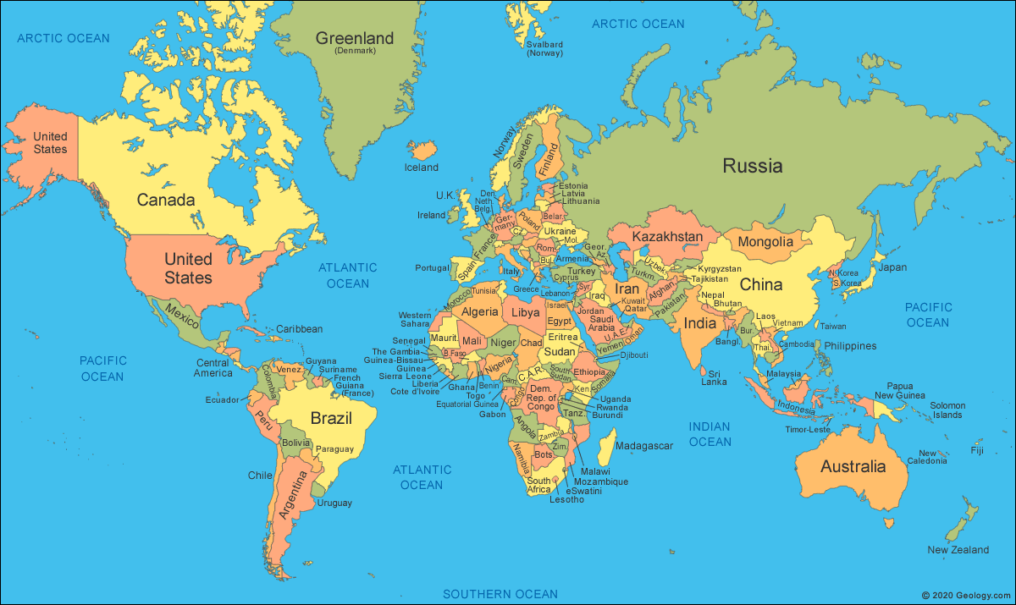  Hong Kong is a ‘special administrative region of China’ which means that it is technically part of China.  Part of Hong Kong is physically joined to mainland China, and part of it is divided into 236 islands.  England to Hong Kong Flight path:  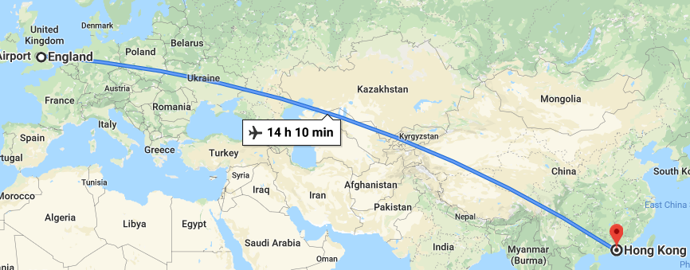  Hong Kong International Airport is built on reclaimed land from the sea, north of Lantau Island.  On a flight from the UK to Hong Kong, you would fly over: Poland, Germany, Ukraine, China  The journey from the UK to Hong Kong is approximately 10,000km. | Regions  Hong Kong is divided into regions:  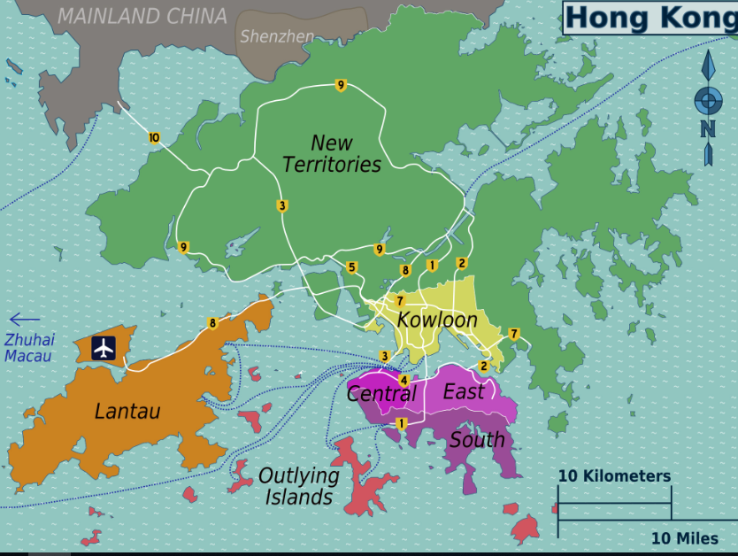  - From Lantau Island to ‘Central’ on Hong King Island, you could take a bus, taxi or train.  - Central to Lamma Island - you would need to catch a ferry, taking you across the Lamma Channel (one of the busiest sea lanes in the world).  The city  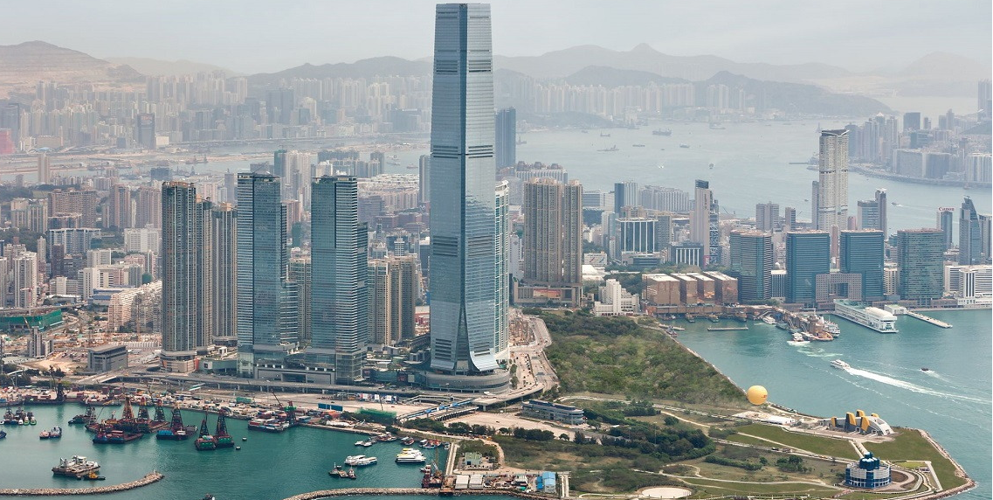  The city has many sky scrapers and a busy harbour with many export and import cargo ships as well as ferries travelling between the islands. | Accommodation  In ‘Tai O’ (a traditional fishing village) the houses are built on stilts and are very small.  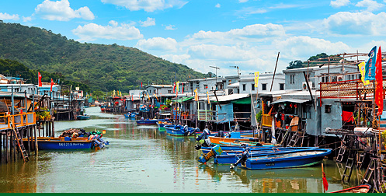  Many people choose to live in small apartment blocks with sea-views, such as places like Discovery Bay.  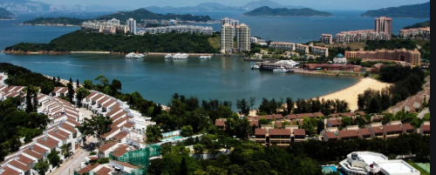  What’s the weather like?  - The climate is warm all year-round (= or >14 degrees C)  - May to September sees the highest amount of precipitation. Rainfall exceeds 300mm every month, causing flash flooding. | General Facts  - Most of the population in Hong Kong are of Chinese ethnicity,  - People come to work in Hong Kong from all over the world. They may be entitled to permanent residency (‘expats’) after a number of years.  - Hong Kong is famous for filmmaking.  - Tourism is a key source of income for Hong-Kong and creates many jobs.  - Pollution and waste management cause problems.

