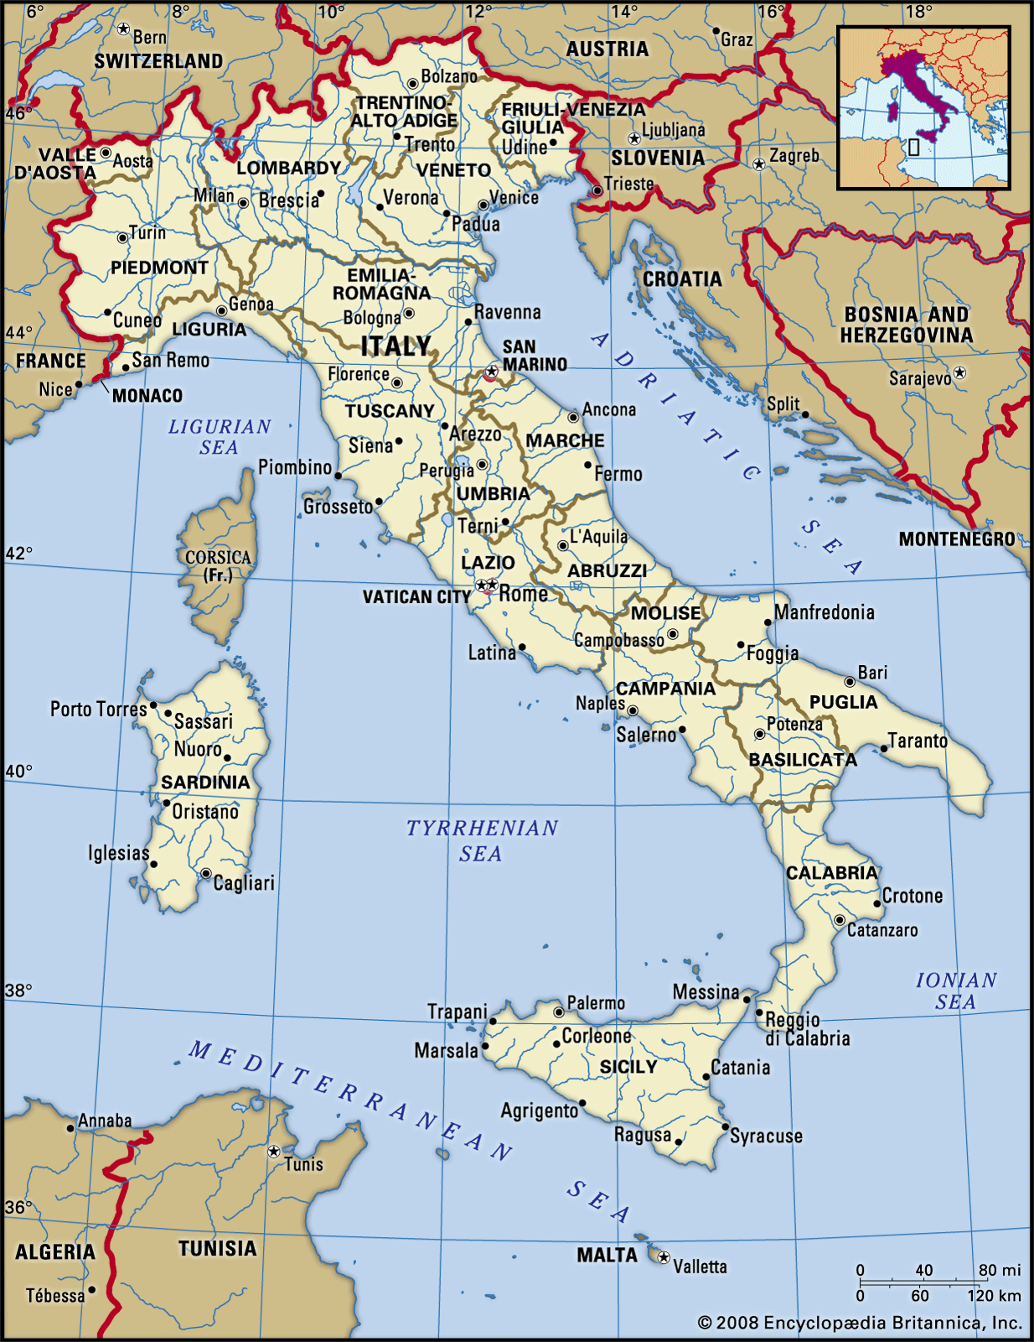
- A country in the continent of Europe.
- Its mainland is in the shape of a boot.
- As well as having a mainland, Italy also includes 450 islands.
- Its capital city is Rome.
- Italy is in the Northern Hemisphere but southern Europe.
- Italy’s neighbouring countries are France, Switzerland, Austria and Slovenia.
- There are 4 marginal seas that surround Italy: Adriatic, Ionian, Tyrrhenian, Ligurian.
- The Mediterranean is the large body of water between Southern Europe and Norther Africa. It leads out to the Atlantic Ocean.

Key Facts
- There are diverse 20 regions of Italy.
- There is a mountain range called the Alps in the north.
- Mount Blanc is the highest Mountain in the Alps (4,808m high). It is the 11th highest mountain in the world.
- Italy is a popular place for tourist because of the climate, history and location.
- Mount Vesuvius is an active volcano situated above the Bay of Naples in southern Italy.

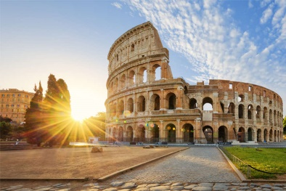
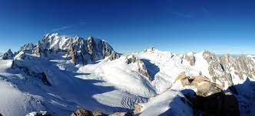
Vocabulary | Definition
Line of latitude: The Equator | The invisible line that runs around the centre of the Earth.  Italy has a warmer climate than the UK because it is closer to the equator and therefore receives a stronger concentration of the sun’s energy. | 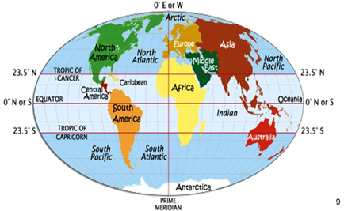
Line of Latitude: Tropic of Cancer | 23.5⁰ to the North of equator.  Italy is not within this, but above.
Line of Latitude:  Tropic of Capricorn | 23.5⁰ to the South of the Equator.  The area between the equator and the lines of Cancer and Capricorn is called The Tropics. Countries in this area receive a huge amount of the sun’s direct energy.
Lines of longitude | Lines that run from North to South  The Greenwich Meridian line is a line of Longitude at 0⁰  Lines of longitude help to split the world into different time zones | Italy’s time zone is called ‘Central European Time’ which is 1 hour ahead of the UK’s ‘Greenwich Mean time’

