|  |  |
| --- | --- |
| **Light key vocabulary** | |
| **Light source** | An object that produces its own light (e.g. sun, candle). |
| **Darkness** | The absence of light. |
| **Reflection** | When a light hits a surface and ‘bounces’ off. |
| **Ultra Violet (UV)** | Rays emitted by the sun that are harmful to our skin |
| **Shadow** | A dark area or shape caused by the blockage of light. |
| **Opaque** | An object which does not allow light to pass rough it. |
| **Translucent** | An object which allows some light to pass through it. |
| **Transparent** | An object which allows light to pass through it so that objects behind it can be easily seen. |

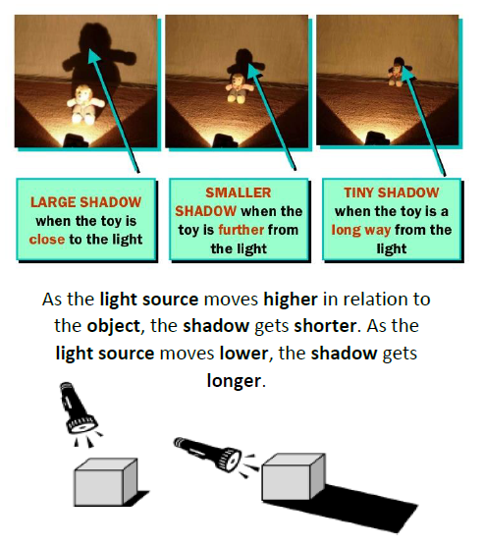

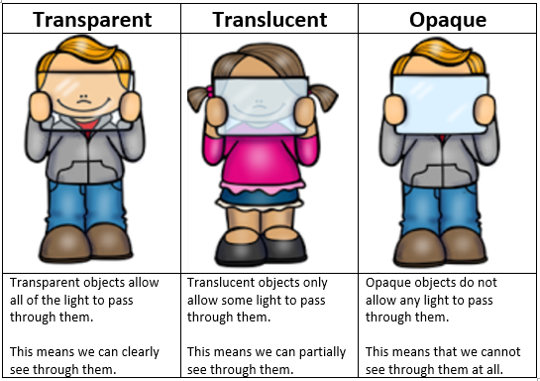

We need to protect ourselves from the Sun’s Ultraviolet (UV) rays

* Never look directly at the sun as it can damage our eyes (wear sun glasses)
* Spend time in the shade between 11 and 3 when the sun is at its hottest
* Use plenty of sun cream of at least SPF 30
* Cover up with a hat and a t-shirt
* Make sure you never burn – you can still burn on a cloudy day!