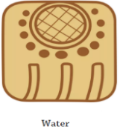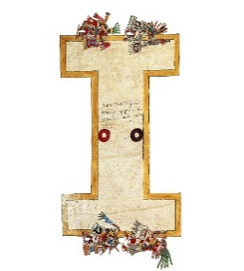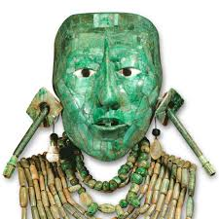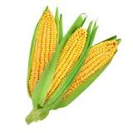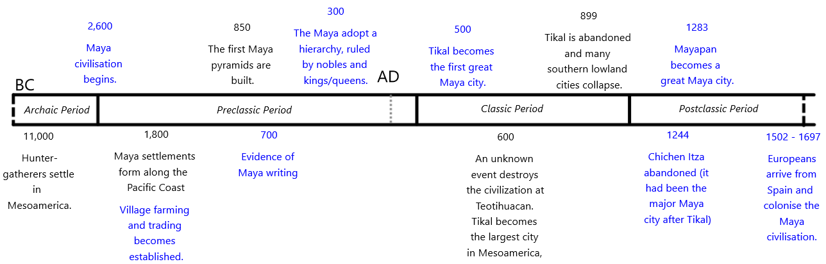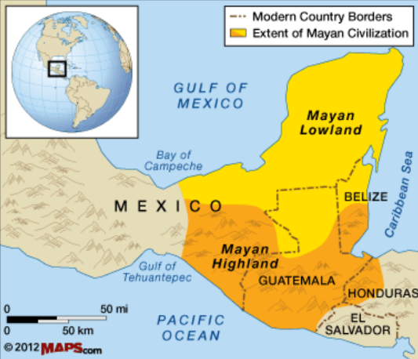

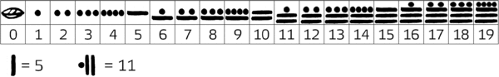

The Maya were expert mathematicians and **astronomers** who used their skills to create complex calendars. They also created a writing system using symbols called **glyphs**. There were around 700 glyphs and we know about them due to the work of **archaeologists**. There was also a Maya numerical system (see image).

Maya cities eventually began to collapse, possibly due to crop failures leading to food shortages.

Some Maya communities continued to thrive until Spanish invaders arrived in the 16th century.

Even today, there are some descendants of the Ancient Maya who live in a similar way, speaking the same language and growing food in the same way.

The Maya created hundreds of cities in Mesoamerica. They usually included: a palace for the ruler, a plaza for the marketplace, and stone step pyramids.

Pyramids were used to make offerings to the gods and as tombs for dead rulers.

Maya Culture

The Maya worshipped many gods. Humans and animals were used in sacrifices to the gods. The Maya believed that kings and queens became gods when they died.

The Maya played a ball game called **ulama.** Evidence suggests that the winners were sacrificed to the gods.

The Maya produced some incredible artwork, including portraits of themselves and ceremonial masks. These are helpful historical **evidence-sources**.

The Maya civilization developed in the area that today includes:

* south-eastern Mexico,
* all of Guatemala and Belize,
* the western portions of Honduras and El Salvador

The Maya Diet

**\* Maize** (the main food in the Maya diet), vegetables and beans

* Chocolate (only for the wealthy people, also made into a drink)

* Meat (peccary, deer, dogs, rabbits) and fish (hunted by the Maya)

* Rainwater (collected in a **chultun**)

Key Vocabulary

**Mesoamerica:** the historic region of modern-day Mexico and Central America

**Maize:** corn (grown for food)

**Chultun:** an underground storage chamber used to collect and store rainwater

**Glyph:** a symbol to represent a word or sound

**Ulama:** a Maya ball game with two teams

**Archaeologist:** a person who studies history through analysis of artefacts and remains.

**Astronomer:** a person who studies space and celestial objects (e.g. stars)

**Aiaw:** a Maya ruler

**Historical source:** an original source that contains important historical information.