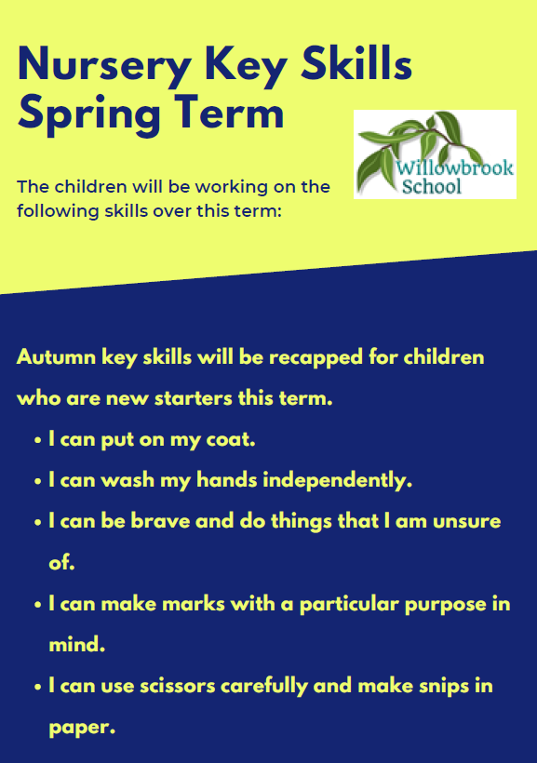

Trips/other reminders

Please remember to return any spare clothes that your child has borrowed.

English

Reading;

‘Jack and the Beanstalk’

‘Jasper’s Beanstalk’

‘The Enormous Turnip’

The Very Hungry Caterpillar’

‘The Teeny Weeny Tadpole’

‘Oliver’s vegetables’

Non-fiction books about- Easter and growing.

Non Fiction: Books about growing

This half-term in

Nursery

Maths

Shape

Weight

Patterns

Size/capacity

Length

Themes

Celebrations- Pancake day and Easter.

Growing

Traditional Tales

P.E

Multiskills- movement and with an object.

PSHE

Exploring the learning behavior-

‘Use your imagination’

*“To provide a transformative educational experience that is based on deep knowledge, nurturing relationships and personal responsibility.”*