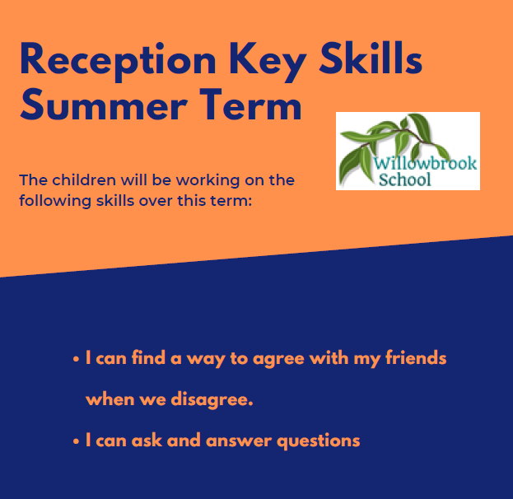

Trips/other reminders

Paignton Zoo

English

What the ladybird heard by Julia Donaldson

Dear zoo by Rod Campbell

The Three Billy Goats Gruff Alperin, Mara

The Gingerbread Man, Pirotta, Saviour

Somebody swallowed Stanley by Sarah Roberts

Stella and the seagull by Georgina Stevens

Night pirates by Peter Harris

The pirates next door by Jonny Duddle.

Summer Term in

Reception

Maths

Number bonds to 10

Bonds within 5

Doubles

Odd and Even

Patterns

Length & height

Capacity & Weight

Time/ Sequencing familiar events

Themes

Animals

Once upon a time…

Seasides

P.E

Outdoor Learning

Sending & receiving

Athletics

*“To provide a transformative educational experience that is based on deep knowledge, nurturing relationships and personal responsibility.”*

PSHE

Exploring the theme of Teamwork in Summer1 and ‘Health and Relationships’ in Summer 2