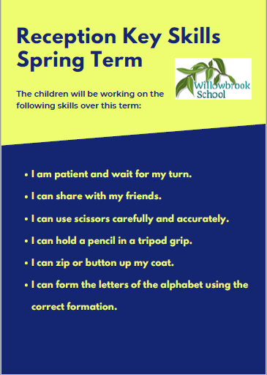

Trips/other reminders

Please remember to send in a White T-shirt and Black shorts for PE on a Friday morning.

Remember Outdoor learning is on a Wednesday.

English

Reading;

‘The Girl and the Dinosaur” by Hollie Hughes

“How to grow your own Dinosaur” by Caryl Hart

“Giganticsaurus” by Jonny Duddle

“Busy Spring” by Sean Taylor

Non-fiction books about- Easter and Dinosaurs.

This half-term in

Reception

Maths

Shape

Weight

Patterns

Size/capacity

Length

Themes

Dinosaurs

Spring & Easter

P.E

Gymnastics

*“To provide a transformative educational experience that is based on deep knowledge, nurturing relationships and personal responsibility.”*

PSHE

Exploring the value

‘Excellence.’