Upper course of a River  - This is the first part of a river’s journey. Usually beginning on high land, such as mountains. Water is flowing quickly and with lots of energy. It cuts a narrow channel through rocky hills or mountains. | Rivers  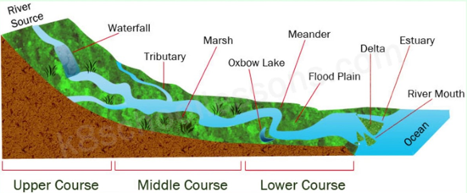  Flooding  can occur at any point along the middle and lower course of a river.  Too much precipitation can cause flooding. When there has been a lot of precipitation in a short time, then the land can become saturated, meaning there is nowhere for the water to soak away.  - flooding is more likely in areas where soils are less permeable.  - urban areas are also more vulnerable to flooding because of the increased likelihood of surface runoff on roads and other harder surfaces.  - Know that the amount of rain within a particular timescale is what contributes towards the likelihood of flooding.
Middle course of a River
- land is flatter and the river is wider.
- tributaries (small streams of a fresh water) add water
- river will meander (bend) which causes the river to flow at different rates – slower around the meander itself.
- Oxbow lakes may be formed
- Erosion causes the wearing away of the river banks and river bed
- Abrasion, small rocks and sediment can also act like sand paper, rubbing away at the river bed.
- Attrition also causes rocks and pebbles to collide and break apart.
- Erosion can occur where water reacts with minerals in the rocks it flows over.
- Transportation is the word used to describe eroded material being transported downstream.
- Deposition occurs where water lacks the energy to transport the load it is carrying.
- Know that
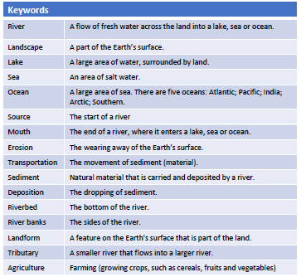

The Amazon River
- longest in South America, measuring 6516km in distance. (18 x River Thames!)
- find Amazon River on a map and identify some of the countries/regions it passes through.
- the Amazon River is the main path of transportation for people and produce in the regions, with transport ranging from balsa rafts and dugout canoes to hand built wooden river craft and modern steel-hulled craft.
- Know that seasonal floods enable dry-season riverside agriculture of rice, beans, and corn on the river's shoreline
- fishing in the Amazon provides additional food year-round.
- more than one-third of all known species in the world live in the Amazon rainforest.
There are over 3,000 species of fish with more being discovered every year.
- Know some key similarities and differences between the final cities both the Amazon and the Thames run though (Belém, Brazil and London, England) - tourism, attractions, role of the river, population.
Ordnance Survey Maps
Interpret 4- and 6-figure grid references.
Use a map’s scale and to use this to work out the distances between different locations that the River Thames passes through.
Know what contour lines are and what they represent.
Lower course of a River  - Where the river meets the sea is called the river ‘mouth’. At this point you can find an ‘estuary’, where freshwater from the river mixes with the salt-water from the sea. Deltas are characterised by mud and sediment deposits when the incoming tide cannot wash them away.  - Know that at ‘high tide’ mud and debris is washed away by the sea. | The River Thames  The five longest rivers in the UK: Severn (354km), Thames (346km), Trent (297km), Great Ouse (230km) and Wye (215km)  - Know that there are really different and contrasting places that the River Thames passes through  - Know and describe some simple reasons why London grew around the mouth of the River Thames.

