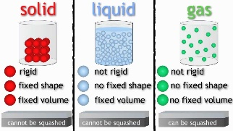
By the end of the unit we will:
- Understand the different states of matter that materials can be in.
- Know how to accurately test and measure how something can change state due to changes in temperature.
- Know how to think more scientifically in the way that we test, record and analyse results.
Key Knowledge
The Water Cycle | Evaporation occurs when the surface of a liquid changes state into a gas because its temperature has become warmer.
 | Evaporation happens as part of our water cycle, when water from our oceans, lakes (and so on) warms-up and turns into vapour.
 | Condensation is the change of water vapour back into liquid water. This
 | Condensation happens within the water cycle when the water vapour high up in the sky begins to cool again, forming droplets of water that join together and fall because of their weight.
 | The rate of evaporation is dependent on temperature. Liquid in an environment with a higher temperature will evaporate more rapidly, whereas liquid in a lower-temperature environment will mean a less rapid rate of evaporation.
 | Different types of liquids evaporate at different rates.

Vocabulary | Definition
Particle | A small portion of matter
Volume | The amount of space that a substance occupies
Water vapour | Liquid that has been heated to form a gas
evaporation | The process of liquid becoming gas
condensation | Water which collects as droplets on a cold surface when in contact with warm air
flow | Move steadily or continuously in a current or stream

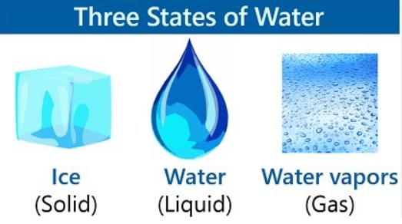
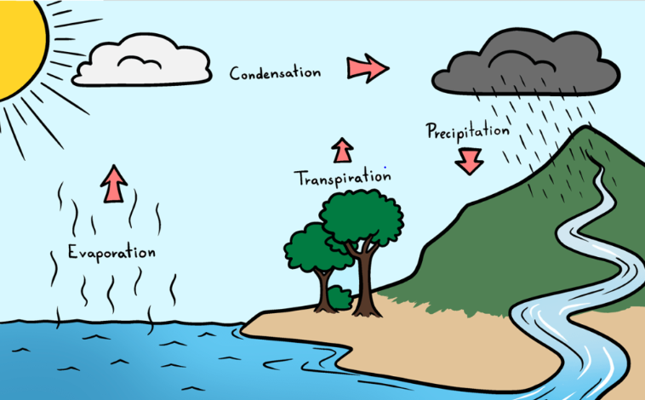
- Know that many materials change state when their temperature changes.
- Know that some materials can take on all three states of matter – e.g. water, which can be a solid (ice), a liquid (liquid water) or a gas (water vapour).
- Know that water vapour is in the air around us all the time, but you cannot see it.
- Know that ‘steam’ occurs (e.g. from a kettle) when water vapour begins to make contact with cooler air, and forms a kind of ‘mini cloud’.
- Know that temperature is measured in degrees Celsius (°C).
- Know that we can measure temperature using a range of equipment, including digital data-loggers and thermometers.

