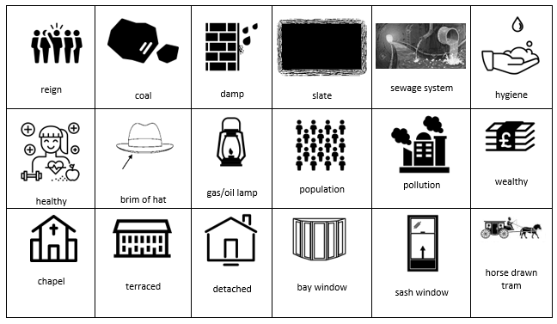
Year 2 Victorians Knowledge Organiser
Queen Victoria

Reigned for 63 years (longest reign in history until our current queen, Queen Elizabeth II).
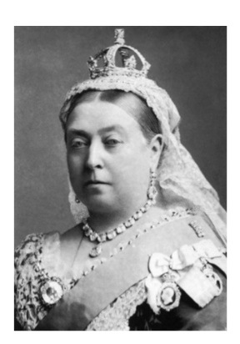

1819  Queen Victoria born | 1837  Queen Victoria became Queen (start of Victorian era) | 1852 – 1854  Cholera outbreak | 1860  Wealthier children rode bicycles | 1880  Schooling became mandatory  Telephones | 1890’s  Motor car travel  1891  Schools became free | 1901  Queen Victoria died (end of Victorian era)
Victorians introduced:
- Police force
- Electricity
- Free schools
- Better sewage systems
- Factories in cities

