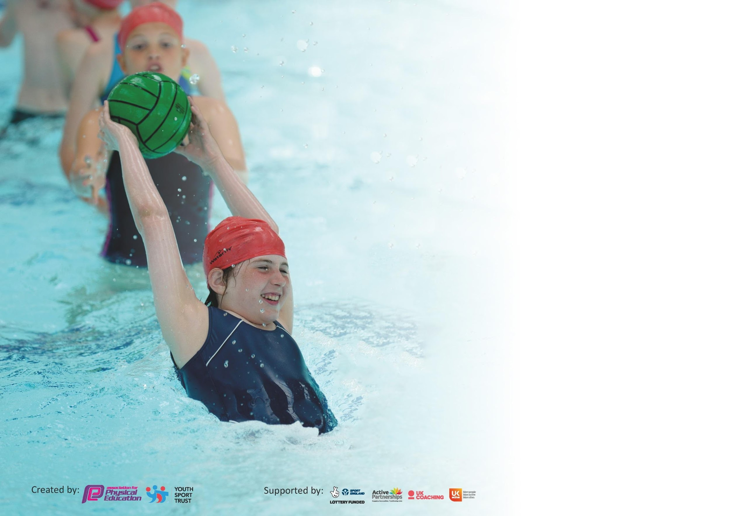

It is important that your grant is used effectively and based on school need. The Education Inspection Framework (Ofsted 2019 p64) makes clear there will be a focus on ‘whether leaders and those responsible for governors all understand their respective roles and perform these in a way that enhances the effectiveness of the school’.

Under the Quality of Education criteria (p41) inspectors consider the extent to which schools can articulate their curriculum (INTENT), construct their curriculum (IMPLEMENTATION) and demonstrate the outcomes which result (IMPACT).

To assist schools with common transferable language this template has been developed to utilise the same three headings which should make your plans easily transferable between working documents.

Schools must use the funding to make additional and sustainable improvements to the quality of Physical Education, School Sport and Physical Activity (PESSPA) they offer. This means that you should
use the Primary PE and Sport Premium to:

- Develop or add to the PESSPA activities that your school already offer
- Build capacity and capability within the school to ensure that improvements made now will benefit pupils joining the school in future years

Please visit gov.uk for the revised DfE guidance including the 5 key indicators across which schools should demonstrate an improvement. This document will help you to review your provision and to report your spend. DfE encourages schools to use this template as an effective way of meeting the reporting requirements of the Primary PE and Sport Premium.

We recommend you start by reflecting on the impact of current provision and reviewing the previous spend.

Schools are required to publish details of how they spend this funding as well as on the impact it has on pupils’ PE and sport participation and attainment by the end of the summer term or by 31st July 2020 at the latest.

We recommend regularly updating the table and publishing it on your website throughout the year. This evidences your ongoing self-evaluation of how you are using the funding to secure maximum, sustainable impact. Final copy must be posted on your website by the end of the academic year and no later than the 31st July 2020. To see an example of how to complete the table please click HERE.

Support for review and reflection - considering the 5 key indicators from DfE, what development needs are a priority for your setting and your pupils now and why? Use the space below to reflect on previous spend and key achievements and areas for development.

Key achievements to date until July 2022: | Areas for further improvement and baseline evidence of need:
- Maintaining a high profile of PE in the school by celebrating children’s achievements.  - All year groups have had the opportunity to take part in after school clubs. | - Promoting family activity and leading active lifestyles  - Refining the curriculum progression  - Resourcing the new curriculum  - For children to have a Swimming curriculum.

Meeting national curriculum requirements for swimming and water safety.
What percentage of your current Year 6 cohort swim competently, confidently and proficiently over a distance of at least 25 metres?  N.B. Even though your pupils may swim in another year please report on their attainment on leaving  primary school at the end of the summer term 2020. | N/A*
What percentage of your current Year 6 cohort use a range of strokes effectively [for example, front crawl, backstroke and breaststroke]? | N/A*
What percentage of your current Year 6 cohort perform safe self-rescue in different water-based situations? | N/A*
Schools can choose to use the Primary PE and Sport Premium to provide additional provision for swimming but this must be for activity over and above the national curriculum requirements. Have you used it in this way? | Yes/No
*No swimming lessons during local Leisure centres being unable to provide the service.

Academic Year: 2021-22 | Total fund allocated: £19,101 plus £7,556 Total: £26,616  Spent: £30,211  £3,505 funded from SBS. | Date Updated: June 2022
Key indicator 1: The engagement of all pupils in regular physical activity – Chief Medical Officer guidelines recommend that primary school pupils undertake at least 30 minutes of physical activity a day in school |  |  |  | Percentage of total allocation:
 |  |  |  | 4%
Intent | Implementation |  | Impact | Total: £725.91
Your school focus should be clear what you want the pupils to know and be able to do and about  what they need to learn and to  consolidate through practice: | Make sure your actions to achieve are linked to your intentions: | Funding allocated: | Evidence of impact: what do pupils now know and what can they now do? What has changed?: | Sustainability and suggested next steps:
Take part in regular exercise on the days the children do not have PE. | Children’s laps are recorded on Golden Mile website.  Monitor teachers use of recording on the website.  Monitor how many children have reached the milestones. | £250 for water bottles – No cost this year. | More children are reaching more milestones, especially children in Reception.  Number inactive children has reduced.  1 chd reached 200 miles.  3 chn reached 75 miles.  10 chn reached 50 miles.  21 chn reached 25 miles. | No ordered made this academic year so will allocate funding in the following year. The subject leader has identified limited stock so will order more that have the new logo on them.  The subject leader will continue to use vouchers from PTA to reward chn with significant milestones. The subject leader will check with the children which shop they would like vouchers in.  The subject leader will discuss with SLT about giving children more opportunities in the day to use the track.
To increase the daily activity during break and lunchtimes by providing children with enough equipment to play with. | Speak to children and MTA’s about what equipment is wanted/needed. | Equipment  Swingball  = £179.94  Portable PA  = £290  Polydron  = £179.99  Soft dice  = £75.98  Total= £725.91 | More children are active during playtimes.  Children enjoy playing with the equipment so they don’t get bored. | This will be budgeted for next academic year to replace lost equipment.  Subject leader will continue to communicate to MTA’s about what equipment is needed.
Key indicator 2: The profile of PESSPA being raised across the school as a tool for whole school improvement |  |  |  | Percentage of total allocation:
 |  |  |  | 55%
Intent | Implementation |  | Impact | Total: £10,557.54
Your school focus should be clear what you want the pupils to know and be able to do and about  what they need to learn and to  consolidate through practice: | Make sure your actions to achieve are linked to your intentions: | Funding allocated: | Evidence of impact: what do pupils now know and what can they now do? What has changed? | Sustainability and suggested next steps:
To celebrate personal and team achievements in celebration assembly and on PE display board. | Regularly update PE board and Twitter page with school teams or individual successes.  Children collect prizes in celebration assembly so parents see the schools success. | No cost. | Golden mile certificates are shared with the children during celebration assembly but not shared with parents. | The subject leader will continue to share children’s success in the Golden mile on social medie & on PE board.
Host events for families to be active together. | Santa run:  Promote event for families to attend and run 1-mile route outside the school grounds.  Timetable Year groups to run the route with Y6 leaders.  Family mile:  For parents to run around running track with their children & earn rewards. | Supply cover:  Vouchers to be funding by Active Devon pilot. | Had significantly more parents take part this year. We had over 70 families run when in the past we have around 40.  Family mile:  Wasn’t able to relaunch due to COVID-19 restrictions. | The subject leader will organise Santa Run to continue to happen in next academic year.  Subject leader to order Exeter City Football trust medals.  The subject leader will organise with SLT about relaunching the family mile.
Installation of Fitness equipment on the playground to be used for Fitness lessons, after school clubs and throughout the school day. | For Y5&6 children to use as part of their Fitness curriculum.  For KS2 children to use during their break & lunch times.  Timetabled in the day for children who access Hub provision to use equipment.  Subject leader meet MTA’s & teaching staff to model how equipment should be used safely. | £16,852  Part of this was from previous Sports funding. | School business manager carry forward funding from previous academic year.  Subject leader provided training for staff once equipment is installed.  The equipment is in constant use a break & lunchtime.  KS2 children have given very positive feedback  “We don’t have anything like it at home.”  “It means your never bored because you can always go on the equipment.”  “We always have something to do now.”  Both Year 5 & Year 6 used equipment in their Fitness curriculum.  Equipment has also been used in several Sport after school clubs. | Subject leader to show new staff how to use equipment safely.  Subject leader to monitor children’s enjoyment from curriculum sessions.

Key indicator 3: Increased confidence, knowledge and skills of all staff in teaching PE and sport |  |  |  | Percentage of total allocation:
 |  |  |  | 40%
Intent | Implementation |  | Impact | Total: £8,577.78
Your school focus should be clear | Make sure your actions to | Funding | Evidence of impact: what do | Sustainability and suggested
what you want the pupils to know | achieve are linked to your | allocated: | pupils now know and what | next steps:
and be able to do and about | intentions: |  | can they now do? What has
what they need to learn and to |  |  | changed?:
consolidate through practice:
All teachers feel confident in delivering a broad range of physical activities. They need to promote physical activity as part of a healthy lifestyle. | Ensure all Unit overviews have clear progression and outcomes.  To ensure there is enough equipment to teach the curriculum at a high standard.  Supply days for PE lead to write overviews & attend PE conference.  Meet with new staff and model good Real PE lessons.  Teachers working alongside Premier coach for one-half term a year. | Supply=  £  Subscription to Create development  £495  Total= £ | Real PE training gave clear instruction on how to deliver curriculum and the reason it is needed for children at Willowbrook.  Met with all teachers to discuss strengths and areas for development in curriculum.  Staff are using the sport specific resources but this need to develop into Invasion games particularly Football.  The is also a need for Dance training as every teacher who taugh this unit looked for support from subject leader. | The subject leader will monitor Real PE lessons.  The subject leader will continue to develop ‘how to guide videos’ as these were used in Strike & Field lessons.  The subject leader will continue to develop skill application videos as teachers used these in summer term for Cricket & Rounders.  The subject leader will support ECT with delivering Real PE lessons.  The subject leader will arrange for Real Dance training in the following academic year.
 | Exeter Chiefs deliver curriculum alongside teaching staff.  Premier deliver curriculum alongside teaching staff. | E.Chiefs:  £4,130  Premier:  £2448 | Teachers fed back they are learning different drills or organisation skills from coaches they have worked with.  Y4 said they had learnt would feel more confident with teaching Frisbee since working with Premier coach. | In following academic year, complete before & after impact form for teachers to complete when working with coaching staff.
To ensure staff have enough equipment to teach high quality PE lessons. | With the new curriculum, we will need:  Rechargeable stopwatches, batting tea, ball pumps, shin guards, beanbags, grip balls, size 3 & 4 footballs. | Equipment  Total= £1,504.78 | More equipment was purchased to accommodate COVID restrictions on sharing equipment across bubbles. This meant lots went missing due to being spread across the school.  Replaced Balance bench as previous ones failed safety check. | Subject leader to audit resources to keep track of annual replacement of equipment.  Subject leader to budget for repairing any other equipment that needs replacing.
Key indicator 4: Broader experience of a range of sports and activities offered to all pupils |  |  |  | Percentage of total allocation:
 |  |  |  | %
Intent | Implementation |  | Impact | Total: £3,305
Your school focus should be clear | Make sure your actions to | Funding | Evidence of impact: what do | Sustainability and suggested
what you want the pupils to know | achieve are linked to your | allocated: | pupils now know and what | next steps:
and be able to do and about | intentions: |  | can they now do? What has
what they need to learn and to |  |  | changed?:
consolidate through practice:
Devon Wildlife trust.  Through collaboration with DWT, each year group will experience high-quality outdoor education during each year. | A bespoke ‘Outdoor Curriculum’ has been developed and shared with staff. This promotes:  - Physical activity (including gross and fine motor skills);  - Mental wellbeing  - An appreciation for being outdoors and engaging with the environment. | Total=  £2500 | Children tell us about the impact it has on their mental wellbeing. All children want to participate in these sessions and engage in them respectfully. We have noticed that children who can be harder to motivate in traditional sports engage well with the physical elements of Outdoor Learning. | We are continuing to work with DWT in the following academic year.
All children get the opportunity to participate in active after school clubs. | Each half term Premier coach will lead an after school club for each year group. The year group will rotate.  The after school club will include sports/games different from the curriculum. | Total cost of the year £805 | All year groups had the opportunity. Each clubs attendance was monitored to check children’s attendance.  Arrow Tag was very popular with the children and was requested frequently. All clubs were oversubscribed. | The subject leader will plan for more variation in sports for after school clubs next academic year since Arrow Tag is no longer available.

Key indicator 5: Increased participation in competitive sport |  |  |  | Percentage of total allocation:
 |  |  |  | %
Intent | Implementation |  | Impact | Total: £150
Your school focus should be clear | Make sure your actions to | Funding | Evidence of impact: what do | Sustainability and suggested
what you want the pupils to know | achieve are linked to your | allocated: | pupils now know and what | next steps:
and be able to do and about | intentions: |  | can they now do? What has
what they need to learn and to |  |  | changed?:
consolidate through practice:
All children get the opportunity to take part in competitive sport within Willowbrook school (intra-house). | Each half term plan events for all children to take part in competitive sport.  Aut 1: Dodgeball  Aum 2: Santa Run  Spr 1: Shuffle ball  Spr 2: N/A due to COVID  Sum 1: N/A due to COVID  Sum 2: Sports day | 2x £75 | Santa run took place and all children took part.  KS2 Intra-school competitions took place during after school sessions in Autumn 2. | The subject leader to plan intra school events in the next academic calendar for all children to take part.  The subject leader to plan in themed weeks to encourage active travel to school competitions.  The subject leader will plan in dates to participate in Devon school games which have mostly been online this academic year.
To pay for transport to competitions. |  |  | N/A due to COVID restrictions.

Signed off by
Head Teacher: | M Marlow
Date: | July 2022
Subject Leader: | S Stanbury
Date: | July 2022
Governor: | J Draper
Date: | July 2022

