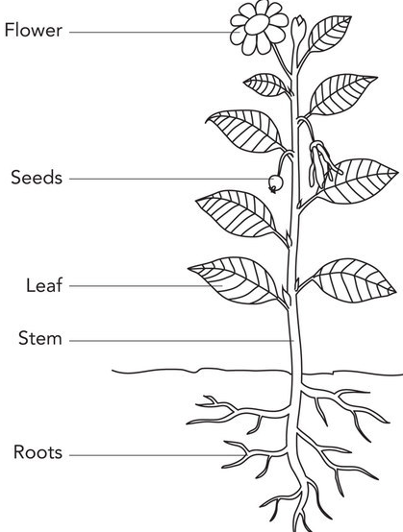
Plants and Animals - Year 3 Science
The part of a plant which allows it to reproduce.
Petals – attract insects.
Allow a plant to reproduce.
Where photosynthesis takes place.
Transports
water to different parts of the plant.
Anchor the plant in the ground and absorb water and nutrients from the soil.
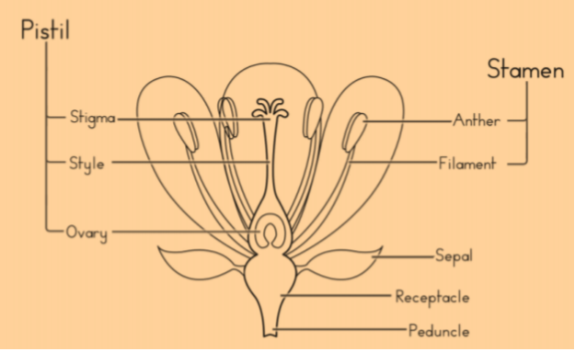
Plants key vocabulary
Pollen | The product of a male part of a plant which allows it to produce seeds.
Ovule | The egg cell which joins with pollen to produce seeds and allows plants to reproduce.
Stamen | The male part of a plant. Includes the anther (produces pollen) and the filament (which holds the anther up).
Pistil | The female part of a plant.  Made up of the stigma, style and ovary (which contains the egg cells called ovules).
Pollination | The process where pollen is transferred to the female parts of the plant which means the plants can make seeds and reproduce.
Fertilisation | When pollen joins with the ovule (egg), a new seed is created.
Seed dispersal | The movement or transportation of seeds away from the plant.
Photosynthesis | The process by which green plants use the sun’s energy from sunlight along with water and carbon dioxide to produce their own food in the form of glucose (sugar).
Transpiration | When water evaporates from the leaves of a plant causing the plant to draw up more water from the roots.

What does a skeleton do?
- Helps to protect vital organs.
- Facilitates movement.
- Supports the rest of the body.

Muscles:
- Main function = facilitate movement (move the skeleton).
- They’re attached to bones by tendons, which allows movement.
- There are more than 600 muscles in the human body!

Animals (including humans) get nutrition from what they eat…
Carbohydrates | Gives us energy.
Sugars | A type of carbohydrate. Gives us a short burst of energy that does not last.
Protein | Helps the body grow and repair itself.
Fats | Provide us with energy. Some stored in our body is good, too much is bad.
Fibre | Helps us digest our food.
Minerals  Vitamins | Mainly found in fruit and vegetables. They are needed to stay healthy.
Iron & Calcium | Iron – needed for the blood. Calcium keeps bones strong.

The requirements of plants for life and growth =
air, light, water, nutrients from soil, and room to grow.

