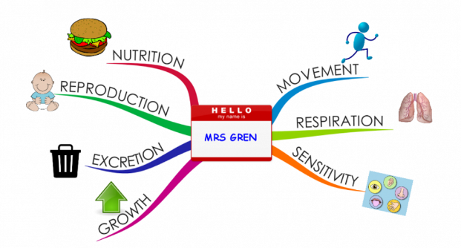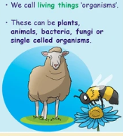Willowbrook School Knowledge Organiser

Year 6: Living things, habitats, evolution and inheritance

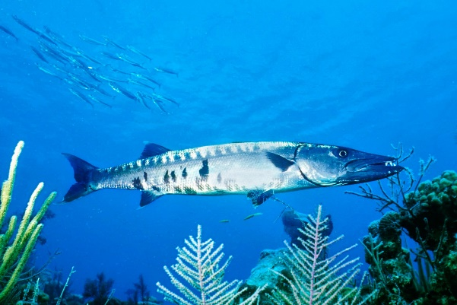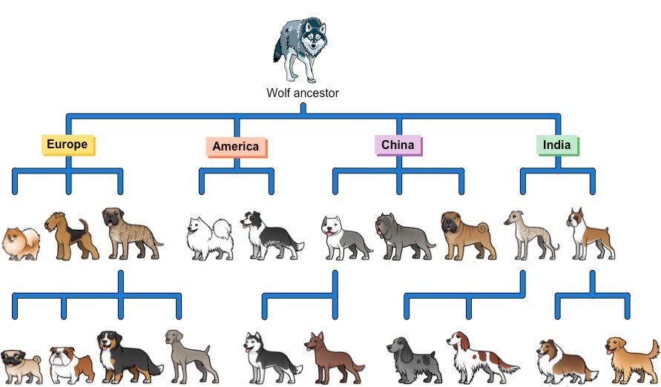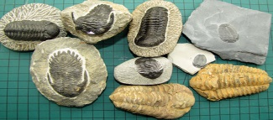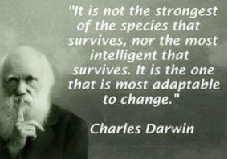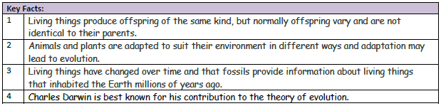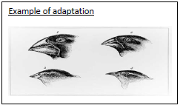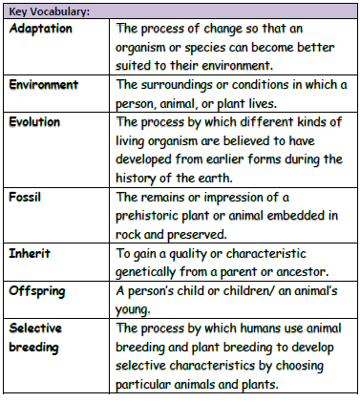

Birds’ beaks are adapted to the environments in which they live and the food available to them.

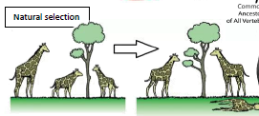

Fossils:

**Fish: a limbless cold-blooded animal with gills and fins living wholly in water.**

Giraffes with longer necks were able to access more food, at higher branches. As those with this trait survived, they passed this trait on to their offspring. Over time, this physical trait becomes more pronounced.

All dogs have a common ancestor. Over very long periods of time, different species have occurred as a result of both adaptation and selective breeding. Selective breeding involves breeding dogs with certain traits with the aim of producing offspring with a particularly desirable trait.