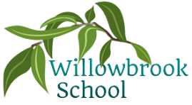

Art

Drawing & painting (fossils)

3D Art – Clay

Music

Hey you! And other hip hop songs

P.E.

Multi-skills

Tennis

Bench Ball

Science

Plants

Geography

Growing & Farming

History

Mary Anning

Trips

Farm Trip

R.E

Jesus as a friend

Palm Sunday

(Christianity)

PSHE

Keeping and staying safe

Computer safety

Our World

Computing

Digital painting

Moving a robot

Spring Term in

Year 1

French

Count to 10

Say my name

Maths

Place value (within 20)

Addition & subtraction

Place value (within 50)

Length & height

Mass and volume

More detailed information for individual subjects that your child will be learning will be on the school website for the corresponding half term. If you would like to know more information about any other subjects then please speak to your child’s class teacher.

English

The building boy by Ross Montgomery

Handa’s Surprise by Eileen Brown

The first book of nature by Nicola Davies

Meerkat Mail by Emily Gravett