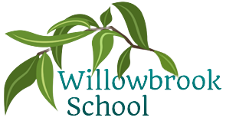

Science

Rocks, Fossils & Soils

Forces & Magnets

P.E.

Dance

Rounders

Outdoor Learning

Athletics

Geography

Italy – Pompeii and Volcanoes

Art

Drawing & Painting: famous Italian artists

Design Technology

Materials – Design an effective moving vehicle

R.E

Hinduism – How can Brahman be everywhere? River Ganges

PSHE

Exploring the theme of ‘teamwork’ and ‘Health and Relationships’

Computing

Desktop publishing

Programming using crumble kits

Summer Term in

Year 3

French

Count to 20

Say my name

Know common colours

Simple conversation

Maths

Fractions

Money

Time

Shapes

Statistics

More detailed information for individual subjects that your child will be learning will be on the school website for the corresponding half term. If you would like to know more information about any other subjects then please speak to your child’s class teacher.

English

Charlotte’s Web by E.B.White

The pebble in my pocket by Meredith Hooper

Street beneath my feet by Charlotte Guillain