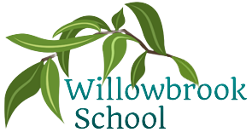

Trips/ Other reminders

Trip to the RAMM museum

Camping on the school field

P.E.

Multi-skills

Cricket

Orienteering

Dodgeball

Science

States of matter

Sound

History

Ancient Egypt

Geography

Kenya

Art

Drawing & Pastels: African Art

Collage pictures using traditional African patterns

Music

African Drumming

R.E

Judaism – Rites of passage and good work

Christianity – Prayer and worship

PSHE

Exploring the theme of ‘teamwork’ and ‘Health and Relationships’

Computing

Audio Production

Programming Games

Summer Term in

Year 4

French

Count to 20

Know common colours

Simple conversation

Food & Drink

Maths

Decimals

Money & Time

Shapes

Statistics

Position & direction

More detailed information for individual subjects that your child will be learning will be on the school website for the corresponding half term. If you would like to know more information about any other subjects then please speak to your child’s class teacher.

English

Journey to Jo’Burg by Beverley Naidoo

Amazing Africa by Atinuke

The eye of the wolf by Daniel Pennac