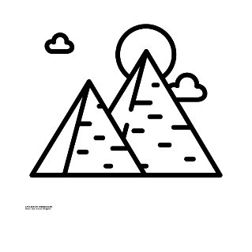

Trips/other reminders

RAMM museum trip

Exe-Factor show!

R.E

Is forgiveness always possible? (Christianity)

PSHE

Exploring the theme of ‘Excellence’

Computing

Scratch coding and crumble kit coding (linked to DT)

Design Technology

Designing a carousel / swing fairground ride with moving parts

This half-term in

Year 4

P.E

Gymnastics and Tennis

(P.E will be on a Tuesday and Friday)

French

Simple conversation

Maths

Fractions and decimals

Continued work on times table facts

*“To provide a transformative educational experience that is based on deep knowledge, nurturing relationships and personal responsibility.”*

English

Reading ‘Christophe’s Story’ by Nicky Cornwell

Non-fiction text: ‘Find out about Ancient Egypt’

History

Ancient Egypt