Year 5 Living things, habitats and animals (including humans) Knowledge Organiser |  |  | All living things need to make more of themselves so that they do not die out.  Reproduction is the process in which new living things are made.  life cycle the series of changes that an animal or plant passes through from the beginning of its life until its death.  metamorphosis. This is when the structure of the bodies of amphibians and insects changes  significantly as they grow (for example, from  tadpole to frog or caterpillar to butterfly).  Humans  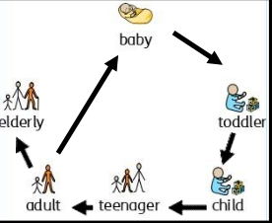
Sexual reproduction of a plant  The stamen is the male part of the flower which holds pollen.  The carpel is the female part of the flower which contains eggs.  Pollen travels from the anthers of one flower to the stigma of another plant. This is called pollination. Plants rely on bees or other insects to carry their pollen while some pollen floats in the wind.  After pollination, the pollen grain and the egg join together= fertilisation.  The fertilised egg will develop into a seed.  Asexual reproduction of a plant  Some plants stems can grow roots if they are planted in the correct conditions. This allows for people to make lots of copies of the same plant.  Runners: Some plants, like strawberry plants, grow runners which have new plants on  the end. These plants are an exact copy (clone)of the parent plant from which they have grown.  Bulbs: Other plants (onions, daffodils and tulips) produce bulbs which will grow if they are planted. The bulbs form under the soil. This helps the plant to survive during the winter months. | 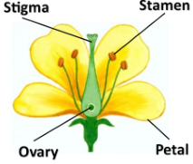 | 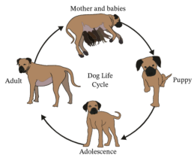  Mammals  - female gives birth to  young  - live young are born  - young looks like adult  - female provides milk  for young.  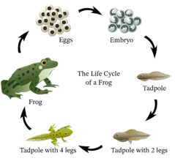  Amphibians  - eggs laid in water  - young go through  different form  before looking like  adult  - no parental care  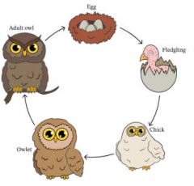  Bird  - eggs laid in a nest  - young hatches from  an egg  - grow to adult  - parental care after  hatching  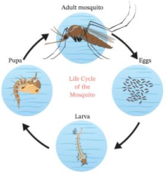  Insect  - eggs laid and then  hatch  - some grow to adult  but most go through  either complete or  incomplete  metamorphosis
anther the part of a stamen that produces and releases the pollen
bulb a root shaped like an onion that grows into a flower or plant
fertilisation male and female gametes meet to form an embryo or seed
germination if a seed germinates or if it is germinated, it starts to grow
ovary a female organ which produces eggs
ovule a small egg cell
pollen a fine powder produced by flowers. It fertilises other flowers of the same species so that they produce seeds
seed the small, hard part from which a new plant grows
stigma the top of the centre part of a flower which takes in pollen
Sexual reproduction
Both the male and female are
needed. Most animals reproduce
sexually.
Asexual reproduction
Only one parent is needed.
This occurs mostly in plants
and bacteria

