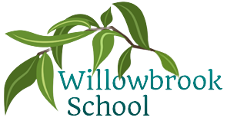

History

Maya Civilization

Trips/ Other reminders

Beach trip after SATs

P.E.

Swimming

Fitness

Cricket

Science

Circulatory System, diet & lifestyle

Sex & Relationships education

Music

Perform in the Y6 production

DT

Sewing: Design and make the set for the Y6 production

R.E

Islam – does a belief in Akhirah help Muslims lead a good life?

PSHE

Exploring the theme of ‘teamwork’ and ‘Health and Relationships’

Computing

Programming games

Programming using crumble kits

Summer Term in

Year 6

French

Count to 20

Know common colours

Simple conversation

Food, drink & the weather

Written elements of all of the above

Maths

Shape

Position & direction

Consolidation & problem solving

More detailed information for individual subjects that your child will be learning will be on the school website for the corresponding half term. If you would like to know more information about any other subjects then please speak to your child’s class teacher.

English

Alma – Fiction

Francis – Fiction

London Underground – Instructions

Dark Sky – Poetry